## How to Enable Voice Typing in Google Docs (desktop version)[1]

**Step 1: Turn on Your Microphone**

To use voice typing or voice commands, your computer microphone needs to be on and working.

**Step 2: Start voice typing in a document**

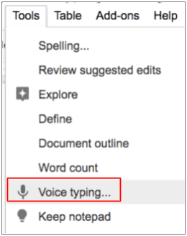

1. Check that your microphone works.
2. Open a document in Google Docs with a Chrome browser.
3. Click **Tools** and then **Voice typing**. A microphone box appears.
4. When you’re ready to speak, click the microphone.
5. Speak clearly, at a normal volume and pace (see below for more information on using punctuation).
6. When you’re done, click the microphone again.



NOTE: The user must be connected to the internet through the Google Chrome Browser on Windows, MacOS or Chromebook devices or on Google Android devices.

1. From Kasey Bell’s <https://shakeuplearning.com/blog/7-reasons-need-try-voice-typing-google-docs/>